**Hotel Management System**

Project Proposal

BS-AI 31’

**Group Members:**

1. Haris Anjum -------2021205
2. Fasih Ali Kazmi ---2021637
3. Haseeb Gulzaar --2021388
4. Harris Zulfiqar ----2021210

**Synopsis:**

A hotel management system is extremely important since it helps to store, organize and manage large amounts of data in a single database. It helps to access and update the required data easily. The data regarding room allotments, prices, customers, staff etc can be easily managed using a hotel management system.

Without a management system, keeping track of such large data becomes difficult, which leads to improper room allocation, lack of customer history, confusion in the stay period of a particular customer which eventually leads to a drastic drop in the hotel profits and results in an inefficient business.

All of these problems can be easily avoided using a management system.

**User Story:**

This management system will have two types of users, the manager and the employees. The manager can log in/out using his particular username and password to ensure authenticity. He can create, edit or delete a customer or employee record. He can access the records using the customer and employee id.

An employee can log in/out using his assigned username and password. An employee will be able to create a customer record or access customer history (if any) using the customer id. He will keep track of the room allotment, prices of rooms, availability of suites, number of days stayed etc.

This management system will help in keeping track of data and will ensure security and authenticity while providing an easy to use UI.

**Technology/Methodology:**

We will follow the process of creating a database which firstly includes the requirement analysis, followed by the conceptual design for which ER/EER diagram would be used. Many tables will be required in this system including a table for customers, one for staff, rooms etc. The ER/EER diagram will help in defining the relations between different entities and help us in the next step i.e. the logical and physical design which is the actual creation of a database using SQL queries.

The information above is not final and is prone to change.

**Git Link:**

<https://github.com/Haris-Anjum/Hotel-MS.git>

**Relation Schema:**

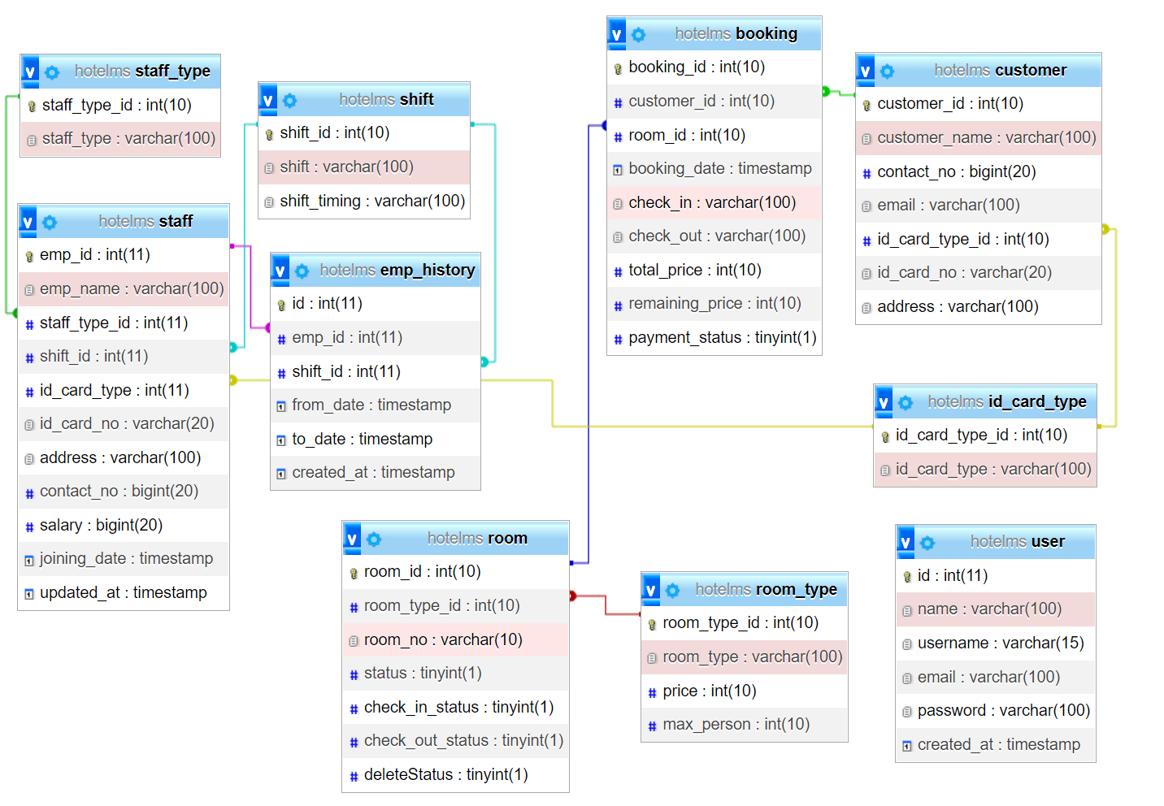

**ERD:**

Makes

SHIFT

ROOM_TYPE

ID_CARD_TYPE

EMP_HISTORY

ROOM

CUSTOMER

BOOKING

OF

has

has

of

has

of

of

USER

STAFF_TYPE

STAFF